- 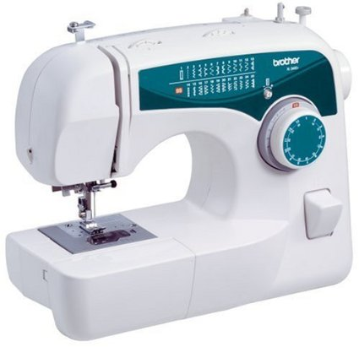

Brother XL2600I Sew Advance Sew Affordable 25-Stitch Free-Arm Sewing Machine

List Price: | $149.99
Price: | $79.99
You Save: | $70.00 (47%)
- Free-arm sewing machine with 25 built-in stitches, each with multiple stitch functions; good for novices and everyday sewing projects
- Accessory storage built into free arm; includes 5 accessory presser feet and bilingual user's manual
- Features needle threader, thread cutter, drop-in bobbin loading, and auto bobbin winding; 1-step auto-size buttonholer
- 110-volt machine operates with foot pedal; light bulb for workspace illumination
- We do not recommend using this machine in countries that do not support 120V AC even if a voltage adapter is in use.

- 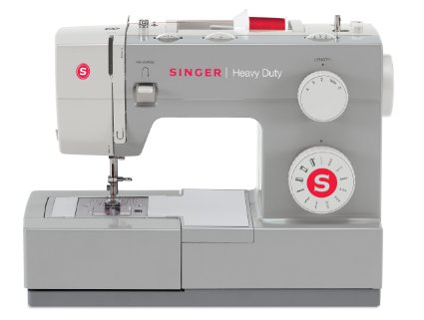

SINGER 4411 Heavy Duty Extra-High Sewing Speed Sewing Machine with Metal Frame and Stainless Steel Bedplate

List Price: | $249.99
Price: | $125.99
You Save: | $124.00 (50%)

Style Name: 4411 Sewing Machine
$125.99 4411 Sewing Machine

$225.98 4411 with Roller Bag

- Extra-High Sewing Speed of 1,100 stitches per minute gives you professional speed for faster results
- Heavy Duty Interior Metal Frame ensures that the machine remains still for skip-free sewing
- Stainless Steel Bed Plate provides smooth fabric feed for even sewing
- 11 Built-In Stitches - essential, stretch, decorative, 1 automatic 4-step buttonhole
- Easy-to-Load Top Drop-In Bobbin System with Clear Cover. 110 volt machine designed for United States and Canadian use only

- 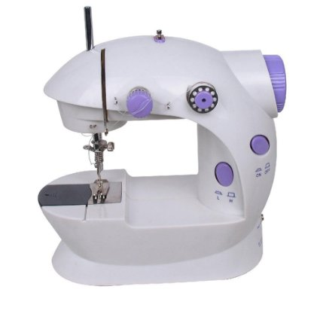

Imax LSS-202 Mini 2-Speed Sewing Machine with Foot Pedal, Purple

Price: | $24.99

Color: purple

- Mini 2-speed sewing machine offers double thread and perfect stitch control
- For anything from silk to denim; hand switch or foot pedal to start
- Top drop-in bobbin ensures easy threading; automatic thread rewind
- This Miniy Sewing Machine is small portable and basic , with easy-to-use features suit for sewing freshman
- If you got sewing machine that no "iMAX" logo ,you can make return request no need for reason.

- 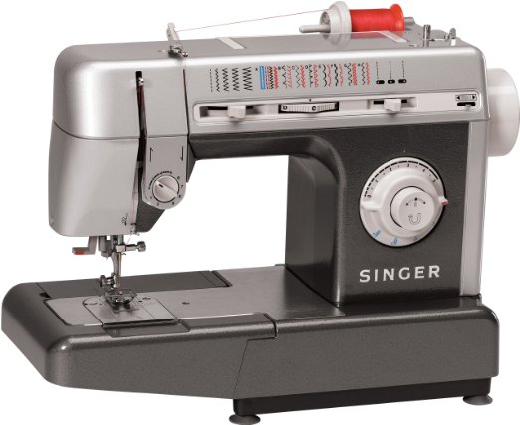

Singer CG590 Commercial Grade Sewing Machine
- Sews at an Impressive 1,100 Stitches Per Minute - When it comes to professional work it is about quality and speed
- Stainless Steel Bed Plate - Made to Accommodate the Abuse and Needs of a Professional Sewer
- 18 Built-In Stitches Including a Four-Step Buttonhole / Free Arm Capability - Sew Pants Legs, Cuffs and other Hard to Sew Garments with Ease
- Drop Feed Capability - Free Motion Quilting to Old Fashion Darning is Easy with the Drop-Feed System
- Exclusive Electronic Foot Control - Guarantees a consistent speed with no jump starts. Includes a regulating dial that allows for slower speeds, regardless of the pressure applied.

- 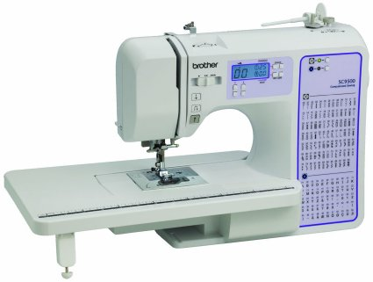

Brother SC9500 Computerized Sewing & Quilting Machine

Price: | $199.99 + $12.99 shipping
- styles of autosize one-step buttonhole and super-wide (7mm) zigzag and decorative stitches
- Automatic needle threading, multiple needle positions and drop feed for free motion quilting
- Includes oversized wide table for quilting and larger projects
- Large backlit LCD screen with computerized stitch selection and brightly lit LED sewing area
- 55 alphabet stitches with built-in sewing font for basic monograming s

